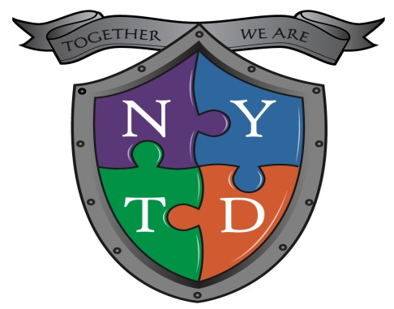
Pennsylvania NYTD Baseline Survey Template
This template is intended to assist IL caseworkers in educating youth about subject matter relevant to their successful transition into adulthood. This information will also be helpful to youth in completion of the Pennsylvania NYTD Baseline survey.
Youth’s Name:

Youth’s Email Address:

Youth’s Phone Number:

Employment: Have you ever been employed? Yes No
If yes, what is the longest period of time you’ve been employed?
0 – 6 months 6 – 12 months 12 months or more

Education: What is the highest grade you’ve completed?

What is the highest education degree/certification you’ve received?

Adult Contact Person:
Name | Phone Number | Email Address | Relationship to You
Health Insurance: Do you currently have health insurance coverage? Yes No

If yes, list name of provider:

Type of Coverage (please check yes or no) | Yes | No
Medical Coverage
Mental Health Coverage
Prescription Drug Coverage
Dental Coverage
Vision Coverage

